الجمهورية اللبنانية
الاسم والشهرة:--------------------

رقم المرشح :----------------------
وزارة التربية والتعليم العالي الامتحانات الرسمية لشهادة الامتياز الفني
المديرية العامة للتعليم المهني والتقني لدورة عام 2018 الاولى
===============
الاختصاص والرمز : المعلوماتية الادارية ( 23104)
المادة : برمجة ويب Web المعدل: (10)
المستندات المسموح بها : لا شيء المدة : ساعتان

- Choose the right answer : (1 pt)
- In canvas, the method that creates an arc/curve (used to create circles or parts of circles) is:
- circle() b. arc() c. bezierCurveTo() d. quadraticCurveTo()
- The property coords.altitude returns the altitude above the mean sea level in:
- meters b. decimeters c. centimeters d. millimeters
- The event that occurs when the user starts to drag an element or a text selection is :
- Ondrag b. ondragover c. ondragleave d. ondragstart
- The property that adds a shadow to text is:
- h-shadow b. v-shadow c. box-shadow d. text-shadow

- Write the corresponding HTML5 and JavaScript tags to create the following 2 files: (3 pts)

File 1 storage.html  As soon as this page is loaded, a dialog box asks the user to enter his name. The entered name is stored locally (with localStorage) in the variable name.  "Enter Website" is a link towards the file "index.html". This link opens in a new page. | 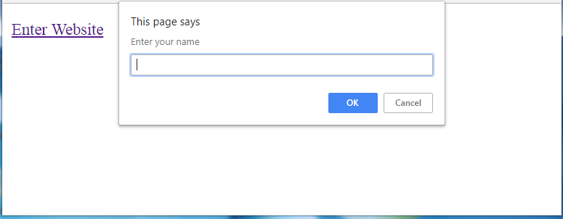
File 2 index.html  This page displays "Welcome" followed by the name already stored in localStorage.  For example, if the user enters the name "Test" then this page displays:  Welcome Test | 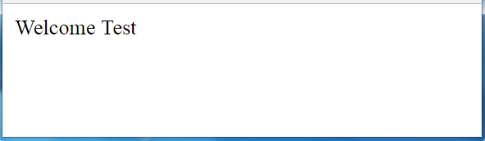

- Write the corresponding HTML5 and JavaScript tags to collect your opinion about a website using a form. (5 pts)
- The field "Full Name" is an input field that must contain at least 7 characters. The test must be done according to a function when we click outside the field (lost focus), in case of error, a message must appear "enter full name".
- Indicate the suitable type for the fields "Email" and "Re-enter Email".
- The values of "Email" and "Re-enter Email" must be identical. The test must be done according to a function when the user clicks outside the field "Re-enter Email" (lost focus), in case of error, a message must appear "value must be the same".
- "How did you find the website" is a radio button where only one choice is possible.
- "Would you recommend our website to a friend" is a field of type range. Minimum value: 1, Maximum value: 10, Default value: 5.
- The field "Comments" is an input field of 3 lines, each line contains 30 characters.
- The button "Send" is used to send the values of the form. When the information of this form is sent, the message "Thank you for your feedback" is displayed in a dialog box.
- The "Cancel" button restores the default values to all fields.
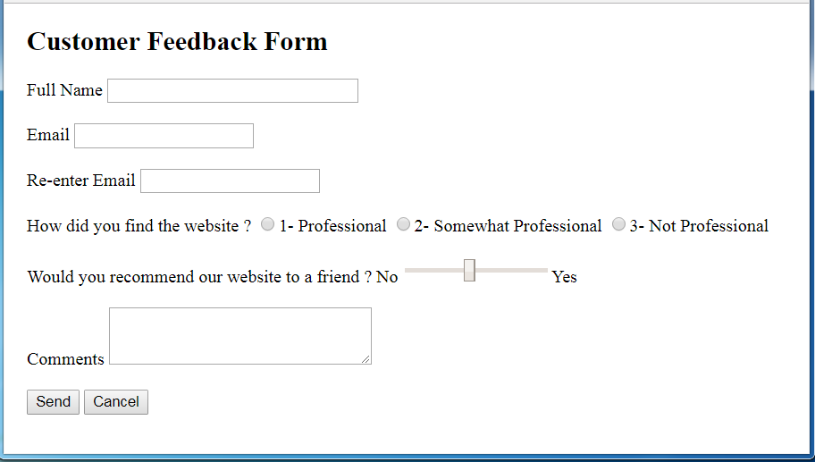

الاختصاص والرمز : المعلوماتية الادارية ( 23104)
المادة : برمجة ويب Web

- Write the appropriate HTML5 tags and the appropriate CSS properties to obtain as a result the page mentioned to the right: (4 pts)  - The first line "Formations" is considered as the most important title.  - The font type of the first line is: Arial.  - The font color of the first line is: Red.  - "Top of Page" is a link towards the beginning of the page.  - The numbers and the bullets are lists. | 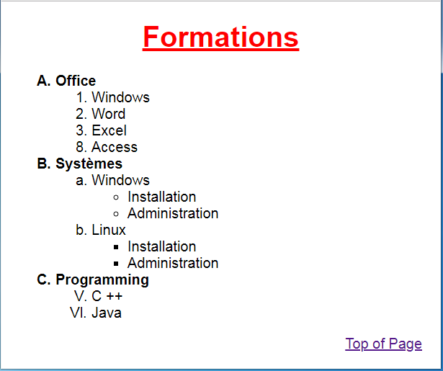
- Write the appropriate HTML5 tags and the appropriate CSS properties to obtain as a result the page mentioned below: (3 pts)
- This page contains 3 paragraphs.  - Each paragraph have the following characteristics:  - Width: 200 pixels  - Height : 75 pixels  - Border type : solid  - Thickness of the border: 2 pixels  - Rounded Border: 25 pixels  - Space between the border and the text: 10 pixels  - Text size: 1.2 em  - The second paragraph « TS1 » is positioned 70 pixels from the top and 60 pixels from the left of its normal position. |  | 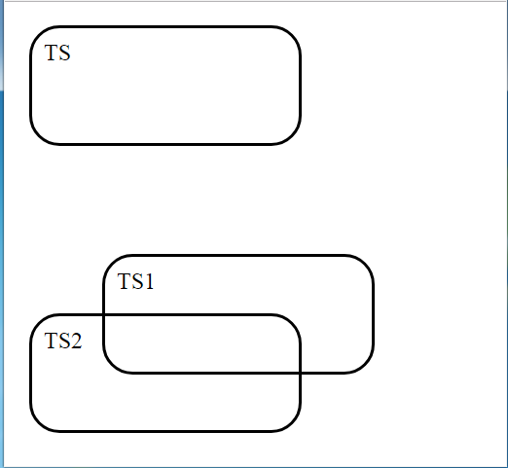
- Write the appropriate HTML5 tags and CSS properties to get as result the page mentioned to the right: (4 pts)  - The table has the following characteristics:  - Width: 550 pixels  - Height : 300 pixels  - Border type : solid  - Thickness of the border: 3 pixels  - Border color: blue  - Space between the borders: 7 pixels  - The name of the image is "lab.jpg".  - "REGISTER NOW" is a link to "www.formation.com".  - When the mouse pointer passes over the link (on rollover), the text color of this link turns green and the color of the background turns red.  - For the colors, use the hexadecimal notation, the code rgb or rgba. | 